# PROJECT SMART WATER MANAGEMENT SYSTEM

1. **Objectives**
   1. The proposed smart water management system under the West Bengal Drinking Water Sector Improvement Project has two main objectives:
      1. The first objective is to facilitate the management of customer service at a local level, thereby greatly increasing customer and community engagement with the new system, which will lead to greater sustainability of the system through:
         1. increased ownership and valuing of the new piped water supply system;
         2. better revenue collection;
         3. responsible use of water;
         4. efficient operations and maintenance (O&M); and
         5. skilling and employment of local people—a minimum of whom will be 33% women—in basic maintenance of small diameter pipelines, property service plumbing, basic accounting such as bookkeeping, meter reading, and information technology.
      2. The second objective of the smart water management system is to increase the resilience and efficiency of the O&M of the entire system, which will also lead to greater sustainability of the system through:
         1. reduced risk of system failure;
         2. improved compliance with social and environmental requirements;
         3. the development of new and necessary skills within the Public Health Engineering Department (PHED);
         4. improved planning, forecasting, and proactive asset management;
         5. improved response to incidents and emergencies, thereby minimizing their impacts;
         6. improved efficient use of energy; and
         7. improved resilience of the water supply system in countering climate change and disaster-related risks.

# Approach and Methodology

1. The approach and methodology used by the project to achieve the objectives outlined in paras. 1 and 2 are as follows:
   1. Project planning for the new drinking water systems has adopted the strategy of comprehensive district-wise approach, connecting the systems on a grid basis where feasible. Where the coverage of the distribution network is limited due to funding constraints, the bulk systems have been sized to allow wider bulk supply to the extent required by the district-wide planning and future expansion. Figure 1 shows an example of such a district-wide system design and planning under the project carried out for Purba Medinipur. This approach will increase system resilience and sustainability;
   2. The new water supply systems are specifically designed to accommodate appropriate technology that will allow smart water management of both bulk and *gram panchayat*-level needs.1 Requirements for the new technology are built into the works contracts for the water supply systems under the project. At the state and *gram panchayat*-level, the proposed grant support under the Japan Fund for Poverty Reduction and the Urban Climate Change Resilience Trust Fund will fund

1 *Gram panchayat* is the village-level (first tier) of the local administrative body of the Government of West Bengal.

2

supervisory control and data acquisition (SCADA) and geographic information system (GIS) monitoring at the PHED. The new technology is designed to be implemented across the entire water supply system using advanced practices and computer technology. It is based on a whole-of-system approach that treats the water supply system as a single operating entity rather than a series of separate but connected components. The distribution network has been designed on district-metering area-based approach. Figures 2, 3, and 4 show the schematic of the smart water management approach and design under the project and how data integration will work to improve operational efficiency;

* 1. ADB’s project preparatory team brought in international and local expertise on smart water management during project preparations to assist with developing the requirements and specifications of the new systems in close consultation with the stakeholders;
  2. PHED (state level) will be responsible for the bulk supply of water into the system up to the boundary of the *gram panchayats* and for major repairs. PHED will also assist the *gram panchayats* in continued technical and utility management training, regulate the services, and assemble and integrate the expertise required to develop the smart systems that will deliver operational efficiency and reduce failure risk;
  3. The *gram panchayats* will be responsible for the management of the distribution network and minor repairs of the new system. This will help in fostering local ownership while providing opportunities for local employment and skills to sustain the benefits of the water supply systems and improved health impacts; and
  4. Training and capacity building programs are developed and will be delivered to target the exact skills that will be required at both PHED and *gram panchayat* levels for smart water management. The project will strengthen the integrated management information systems at central, state, and urban local body or village levels for project implementation and monitoring of water quality and benefits realized.

3

# Figure 1: Example of the Grid-Based Bulk Supply System in Purba Medinipur District

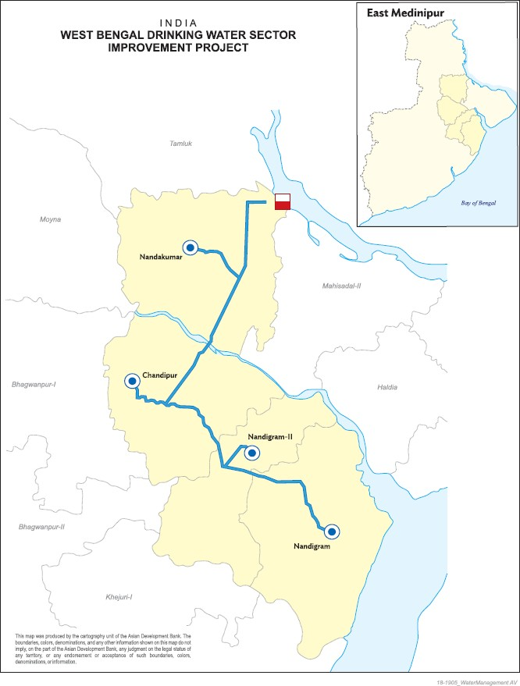

4

# Figure 2: Schematic of Smart Water Management under the Project

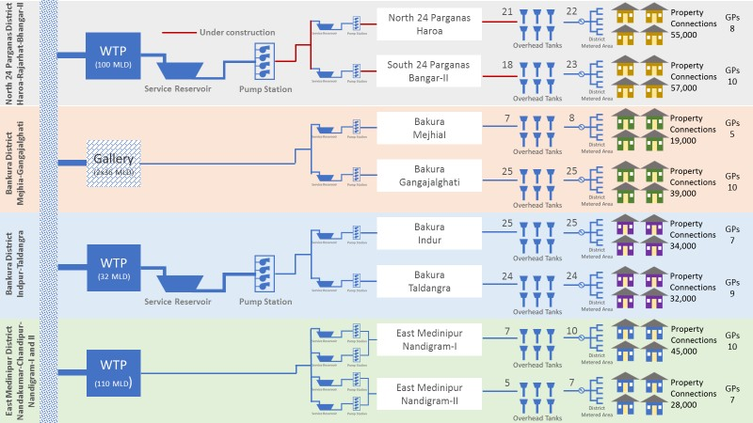

5

# Figure 3: Data Integration under the Project’s Smart Water Management

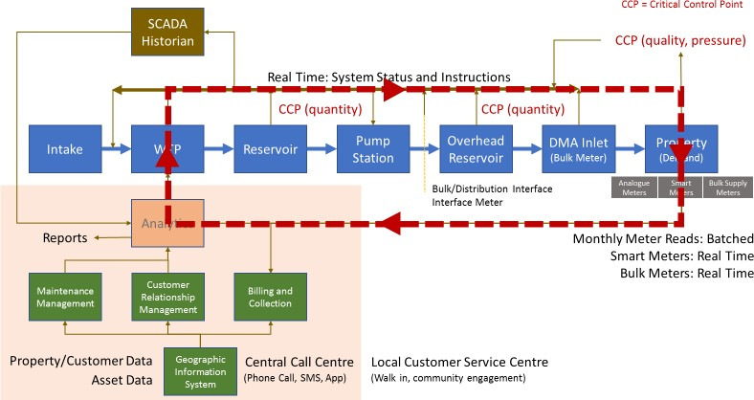

6

# Figure 4: Smart Water Management Functions under the Project

